
Jiminy Crickets! It’s Hot Out!

- Modeling the Temperature using Snowy Tree Cricket Chirps
- Comparing Models

Crickets are one of nature’s more interesting insects, partly because of their musical ability. In England, the chirping or singing of a cricket was once considered
to be a sign of good luck. In China and Japan, they were kept in fancy cages in the house so the residents could enjoy their singing. Oh… and the most famous cricket of all is … Jiminy Cricket!

Go to
Oecanthinae

Use your earbuds if in a public place and listen to some of the different variety of crickets at the website. Definitely listen to the snowy tree cricket. Can you count the chirps?

History
Amos Dolbear developed an equation in 1897 called Dolbear’s Law. He arrived at the relationship between number of chirps per minute of a snowy tree cricket and temperature. You can use this law to approximate the temperature, in degrees Fahrenheit, based on the number of chirps heard in one minute. (N is “X” and T_{F} is “Y”)
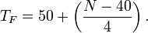

T_{F} in degrees Fahrenheit from the number of chirps per minute N:

Fun Facts
- Male crickets rub their wings, not their legs, to chirp. The male cricket rubs a scraper (a sharp ridge on his wings) against a series of wrinkles or “files” on the other wing. The tone of the chirping depends on the distance between the wrinkles.

- Crickets will not chirp if the temperature is below 40 degrees Fahrenheit (°F) or above 100 degrees Fahrenheit (°F). Why?

Discussion Questions:
Can we use cricket chirps to determine temperature?

Excel Weeks 3-4 Math 422: Using the data set below:

- Create a scatter plot of the data.

- Determine the model that relates chips to temperature and find the equation using appropriate variables and function notation. Remember, chirps correlate to temperature. We are trying to figure out how.

- Follow instructions on Statology to create the scatter plot of your data, include the trendline, use the trendline to create a 3rd column of “predicted” y values which we call “Y-Hat”. Then calculate the residuals in a 4th column.

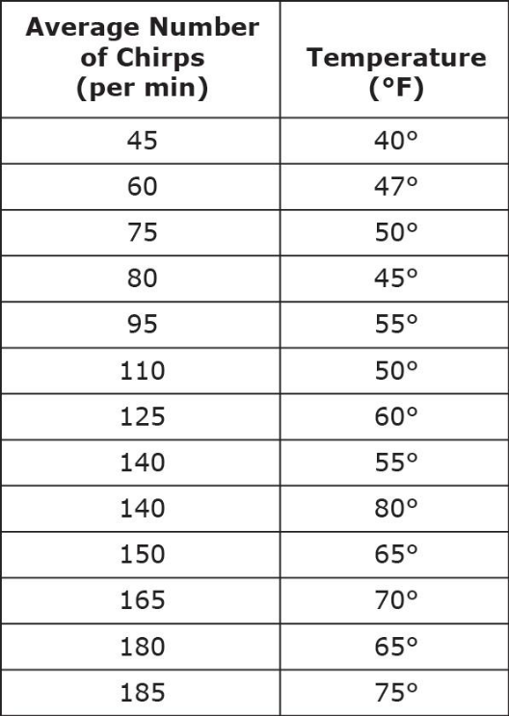

Model (Trendline) and R² value: Make sure to check both boxes and display these on your plot

Do the residuals support your findings? Create a “residual plot” in Excel.

When you believe you are done, check your work against the finished screenshot that I have provided for you before submitting your work. The purpose of this assignment is to learn, so please make all the necessary corrections before submitting.

NAME______________________________ DATE___________________
Week 3 quiz:
Graph Dolbear’s equation in Desmos. Keep that graph and also graph the trendline that you found in Excel. Describe how the graphs compare and contrast by answering the following questions:

- Simplify Dolbear’s equation (get rid of the () and combine “like” terms)

__________________________

- What are the slopes: Dolbear’s________ Trendline________? (round to the nearest hundredth)

- What are the y-intercepts? Dolbear’s________ versus Trendline__________

- The two lines are very nearly ______________.
  - Perpendicular
  - Parallel
- Make your own prediction of the temperature if the count of chirps is 90 in one minute. Give your answer as a number with +/- a margin of error. In a sentence or two, explain how you came up with your answer.

Other models :

• The snowy tree cricket is the species whose music is most in tune with that
of the temperature since it is believed to be the most accurate. For this
cricket, you need to count the number of chirps in 14 seconds and add 42 to
obtain the temperature in degrees Fahrenheit. [By the way, this model is in the middle of our Trendline and Dolbear’s model].

And yet here is another model determined by a woman in Colorado:

Cricket temperature in degrees Fahrenheit = number of chirps in 15 seconds + 37.

How does this model compare to what you found above? Why is it hard to compare?

How could you test the model?

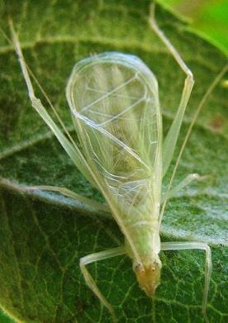
Cricket Chirp Calculator- NOAA
http://www.srh.noaa.gov/epz/?n=wxcalc_cricketconvert

A snowy tree cricket.

